We will explain the GUI main window by parts.

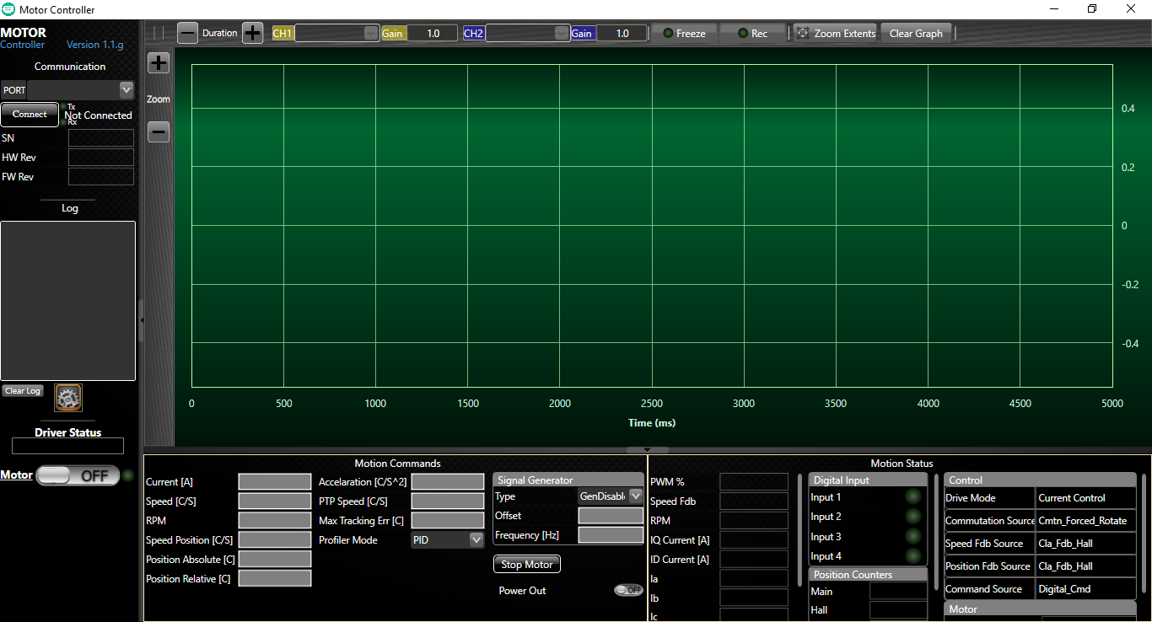

Left panel area:



1 – Application version

2 – COM port selection, if port detected at application starting time, the port will be selected by default, if many COM port are detected you will have to choose from the combobox list.

3 – Connect button allow to open the selected COM port to establish communication with the unit. The status of the connection is at the right and side of the button. Tx and Rx led represents the received and transmitted data between the PC and the unit.

4 – Those parameters are updated when the communication established.

5 – Log section allow you to see some running processes of the application.

The timestamp shows only minutes and seconds. e.g.

34:07 - Failed

34:06 - Autobaud process...

34:06 - Success

34:06 - Connecting at COM5

6 – Clear log allow you to erase the log data.

7 – Open the unit parameters window.

8 – Driver Status display if the driver has no error or specify the error if there is one.

9 – Control the motor status.

10 – Green round led, display the motor status.

1

2

3

4

5

9, 10

6

7

8

Top panel area:

1

2

3

4

5

9

6

7

8

1 – Allow you to increase or decrease time per graph decade.

2, 4 – Graph selection list is update automatically after communication established with the unit. Allow you to display specifics data of the unit simultaneously.

3, 5 – The gain values multiply the displayed data by a gain factor.

6 – Stop updating the graph by performing “pause”.

7 – Record the running graph in an Excel document. *Directory: C:\Users\<name>\Documents\MotorController\Charts*

8 – Fit the graph to the window.

9 – Clear the graph area.

Graph area:



1

2

1 – Allow you to increase or decrease amplitude per graph decade.

2 – Graph area. X axis title is Time (ms), Y axis title is updated dynamically depend of the data graph selected.

Bottom panel area:



1

2

1 – Motions Commands area, allow you to send operation to the controller. You can control the motor remotely.

When clicking on the textbox control, the background change to red color, this means you can type a value to send.

When you finished updating the value, you can press enter key to send the value or escape to cancel operation.

All the displayed controller data is refreshed every 3 seconds.

2 – Motions Status area, allow you to see the status to the controller.

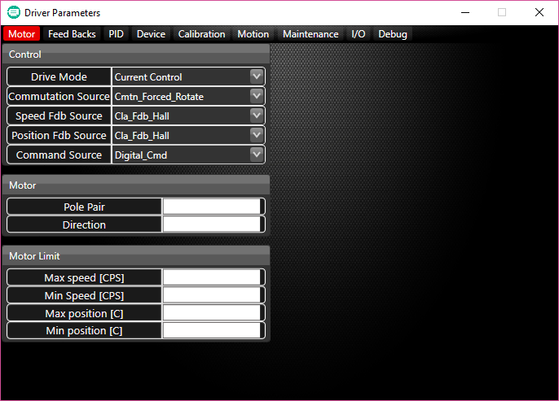

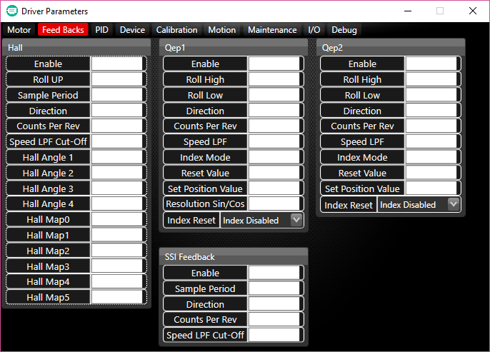

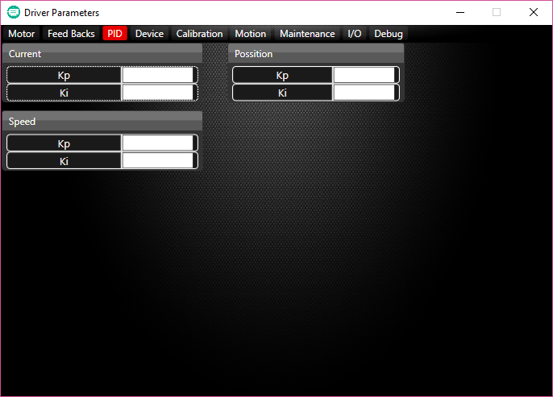

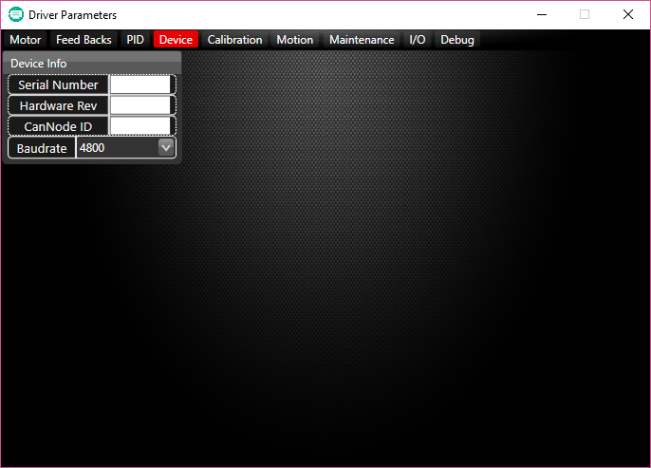

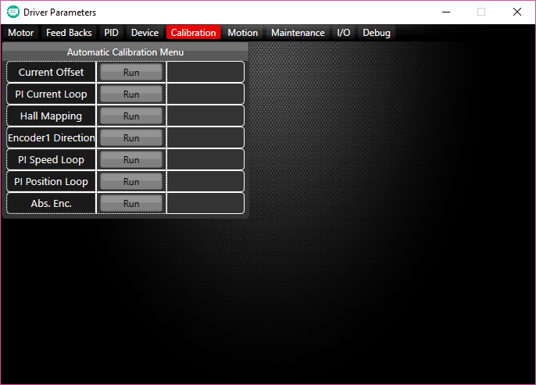

During the calibration:

Idle:

In process:

Success:

Failed:

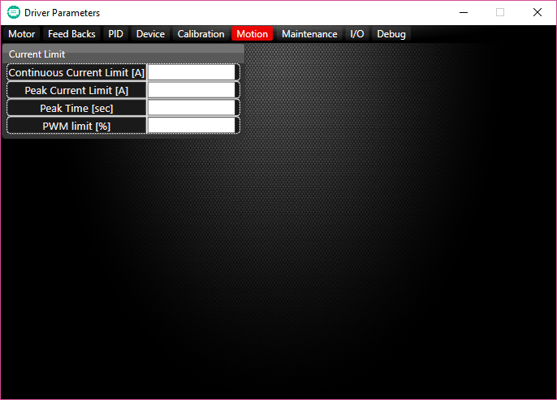

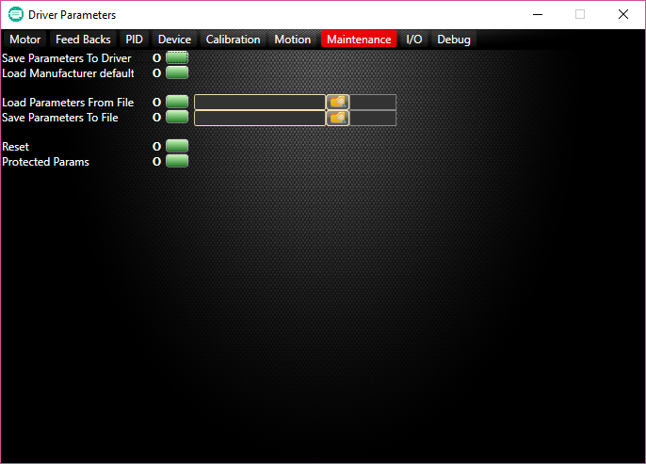

* Save Parameters To Driver: after any change performed to the unit, if you want to them to be saved after a reset you have to perform the save operation. Otherwise the parameters are temporal and won’t be saved.
* Load Manufacturer default: this operation allow you to restore the parameters of the unit.
* Load Parameters From File: you can set parameters to the unit from a file. You have to select the file first. The default directory when the browse window opened is: *C:\Users\<name>\Documents\MotorController\Parameters*

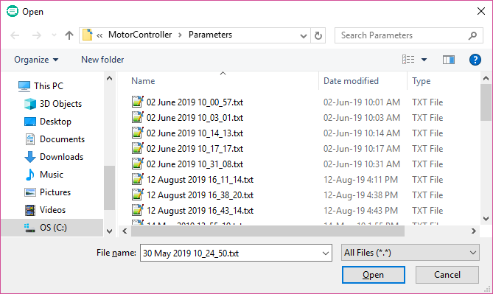

* Save Parameters To File: allow you to save the unit parameters to a text file.

after downloading the data from the unit, you will be prompted to choose a directory and a file name to save the file.

To Open the default directory, click the folder icon. The figure bellow illustrate the opened directory.

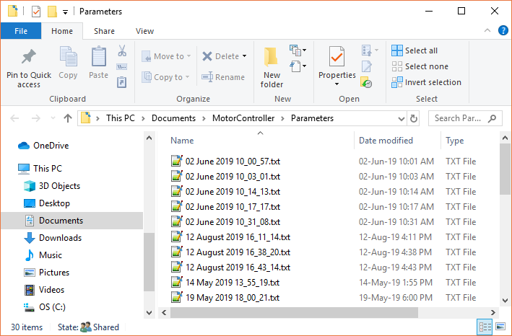

* Reset: send reset operation to the unit.
* Protected Params:

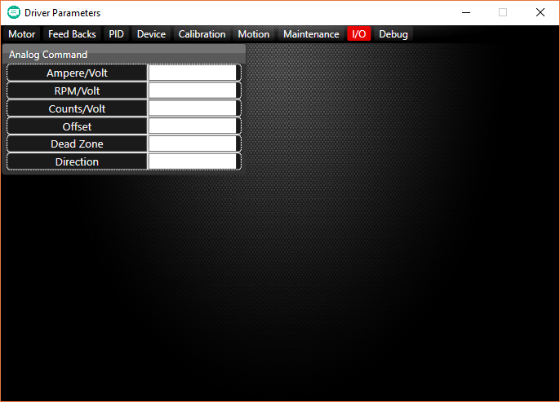

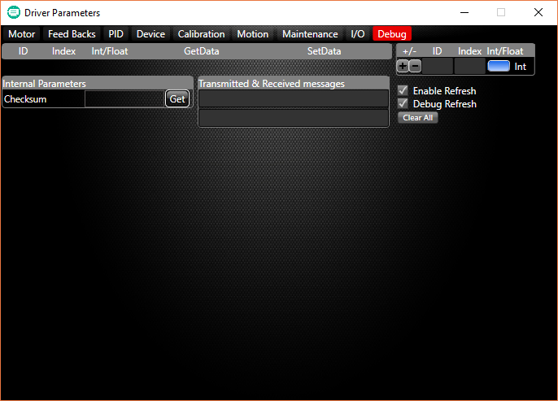

Debug tab: this tab allows you to perform administrator operation.

You can get or set data to the unit specifying the ID, Index and Type parameters.

To add an operation to send, you have to fill the ID, Index and Type values at the top right side of the window, then click on ‘+’ to add the new operation to the list at the left part of the window.

See the figure below after adding two operation (62, 1, Int and 62, 2, Int). 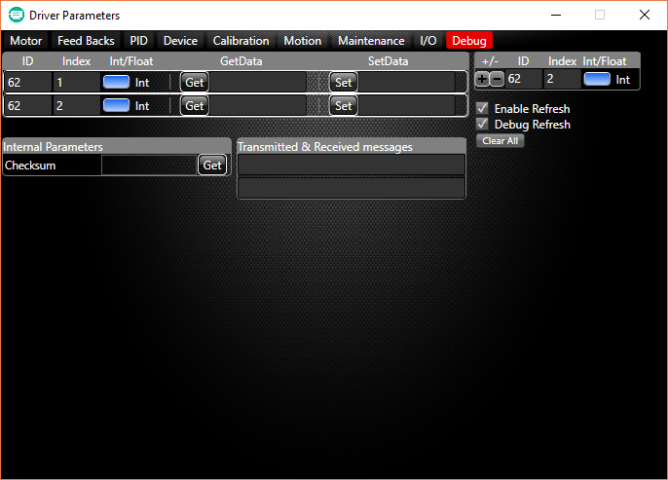

To remove an operation from the list you have to fill the ID and Index at the top right side of the window, then click on ‘-‘ to remove the operation from the list.

You can’t duplicate operation on the list.

Enable Refresh: perform a global refresh of all the visible parameters on the window every 3 second.

Debug Refresh: perform a global refresh of all the operation list of the debug tab every 3 second.

Clear All: remove all the operation you added to the list.

Internal Parameters: you can get the checksum value by clicking on Get button.

Transmitted & Received messages: display the Transmitted & Received data byte of the operation in the list you built.